Setting up your Survey Monkey account/creating a survey
- Account Verification – You will receive an email from Survey Monkey asking you to verify your account. Please log into Survey Monkey through GLCC before clicking the verification link from Survey Monkey.
Here is the path to log into Survey Monkey through GLCC – Other Activities > External Surveys > Next Actions > Manage Surveys

- Once you create a survey, you will have the option to assign a “Collector”
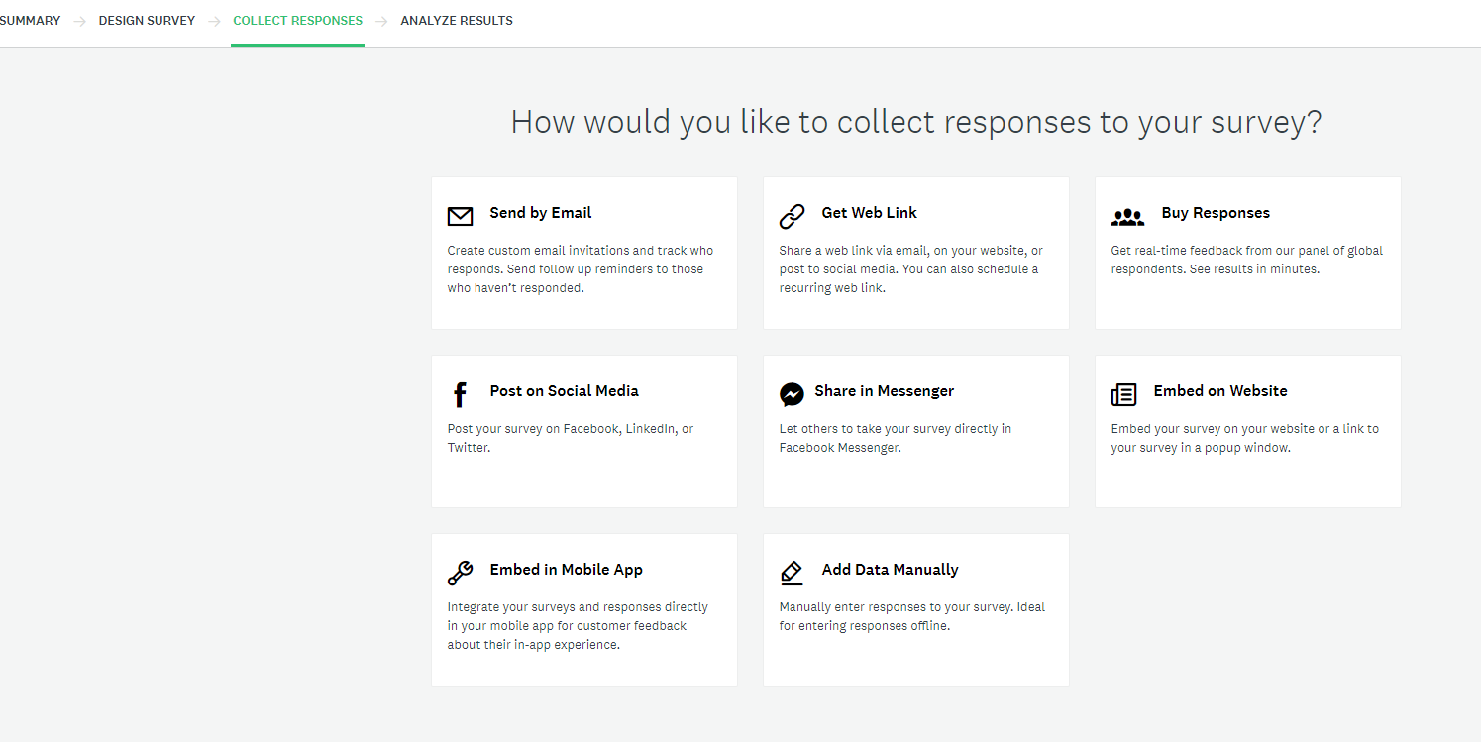
- You should NOT manually assign a collector. You can skip this step, which will leave the survey in a “Draft” status.

- As part of the integration, GLCC will automatically generate Email Collectors within Survey Monkey when the survey is sent out via email to the student/employer. This Email Collector generates a unique URL for each student/employer it is sent to. These surveys are sent manually by Admin through GLCC and the Email Collector is generated at that time.

Linking Created Surveys Into GLCC

- Once surveys are created in Survey Monkey, the Admin must manually refresh in GLCC for the surveys to pull over. Other Activities > External Surveys > Next Actions > Refresh Surveys
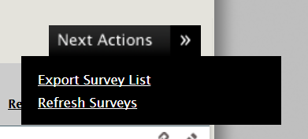

- Your surveys will now be listed on their External Surveys grid under the “Open” tab
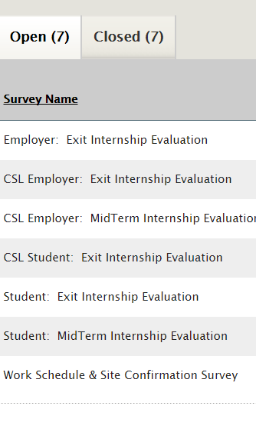
- You must now edit each survey using the “pencil” icon to make it active and choose which “Audience” the survey is for. “Active” determines whether the survey will be an option to send to students/employers when generating the email outreach. “Prompt” will populate a pop-up message for those students/employers who have not completed the survey when they log into GLCC. The pop-up will no longer be in effect once they complete the survey. (“Co-Op/Internship” should only be “Yes” if using the Co-Op/Internship Module)
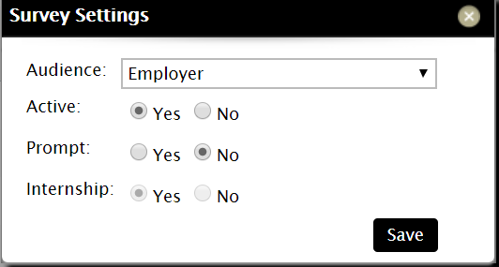

- You are able to send these surveys directly to a single, or group of students/employers. This functionality will appear as an option under Next Actions from the Candidate/Recruiter File grid. Select your population you’d like to survey, then from the Selected Tab > Next Actions > Send Survey
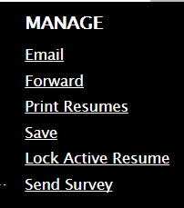

- This action will generate a pop-up email where you can select which survey to send and customize the messaging. Please be sure to always keep the {externalsurveyurl} variable in the message as that will pull in the unique URL from Survey Monkey.
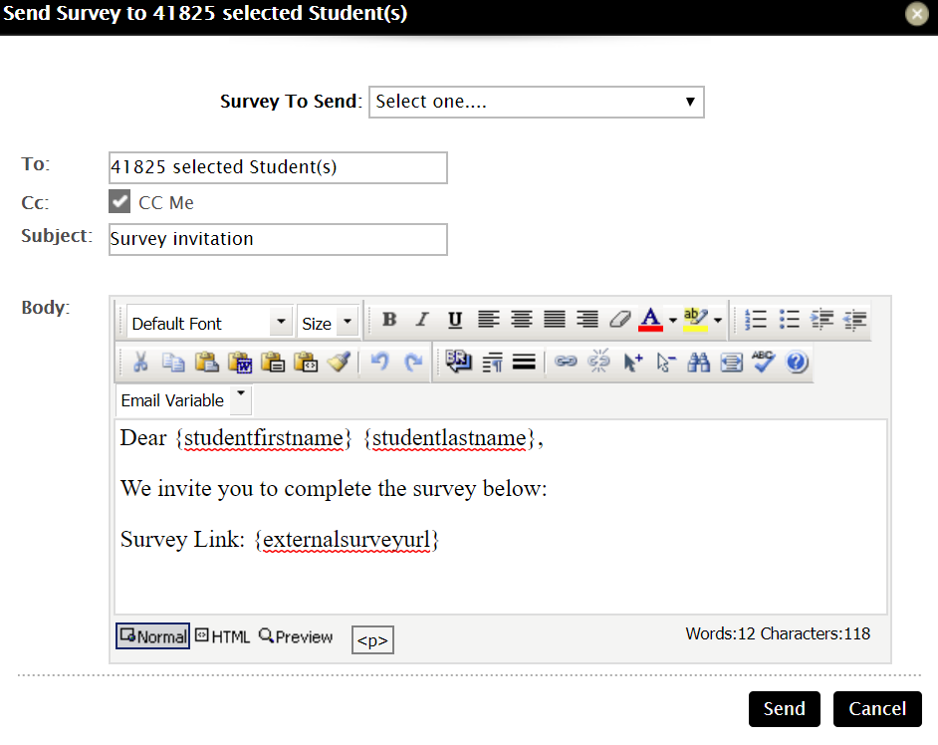

- The results for these surveys can be viewed under each student/recruiter profile under the Action column. (View Surveys)
