External Surveys/Survey Monkey – (Co-Op/Internship Module)

- Account Verification – You will receive an email from Survey Monkey asking you to verify your account. Please log into Survey Monkey through GLCC before clicking the verification link from Survey Monkey.
Here is the path to log into Survey Monkey through GLCC – Other Activities > External Surveys > Next Actions > Manage Surveys

- Once you create a survey, you will have the option to assign a “Collector”
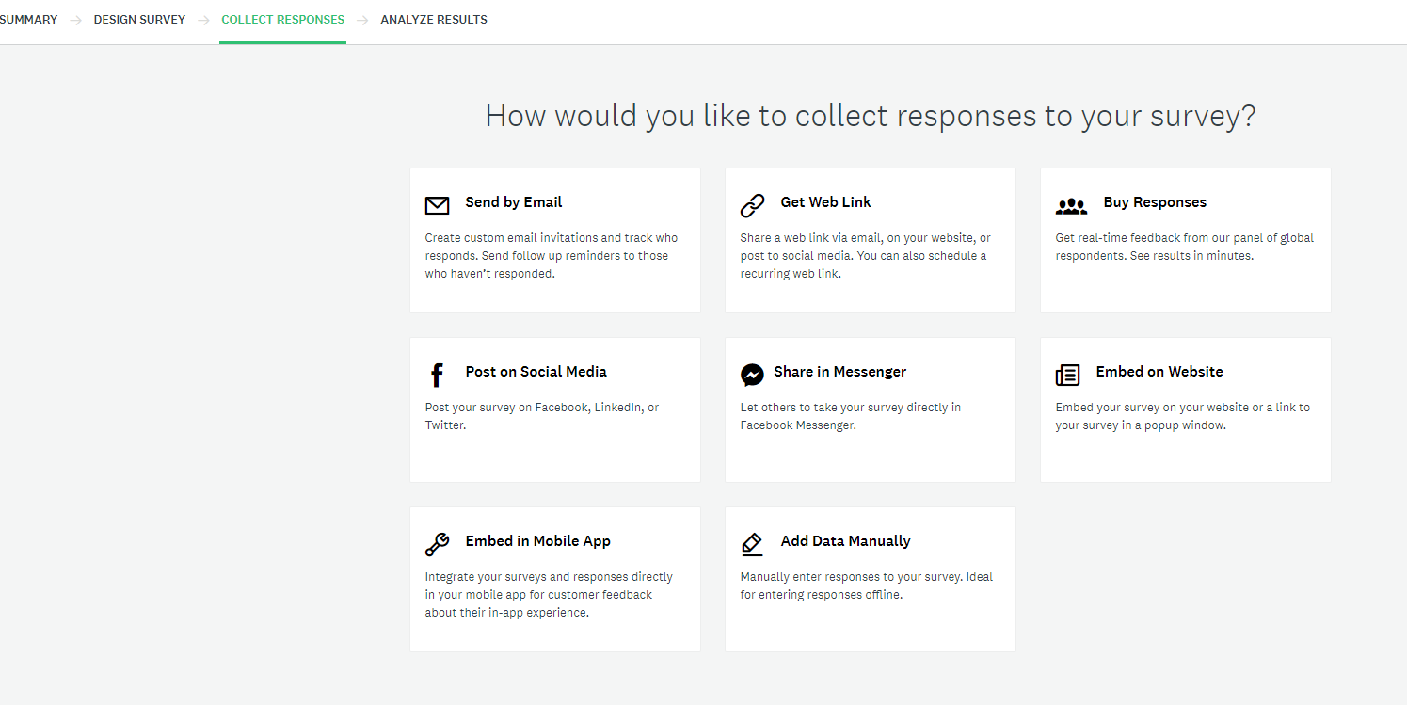
- You should NOT manually assign a collector. You can skip this step, which will leave the survey in a “Draft” status.

- As part of the integration, GLCC will automatically generate Email Collectors within Survey Monkey when the survey is sent out via email to the student/employer. This Email Collector generates a unique URL for each student/employer it is sent to.
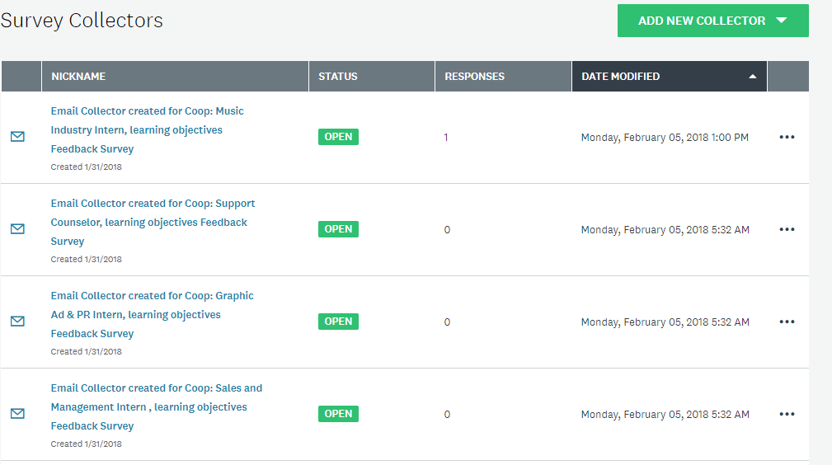
- The surveys are sent automatically based on two scenarios:
- If the surveys are for Co-Op/Internships, they are sent out based on the dates within the Semester List or the actual Co-Op/Internship record itself, since you can modify the survey dates at a Co-Op/Internship record level. The Co-Op/Internship record must be in an Active status in order for the surveys to run correctly. The Active status option will only be available to select once you have a Company and a Contact linked to the Co-Op/Internship record.
- If the surveys are not linked to Co-Op/Internships, they can be sent manually by Admin through GLCC and the Email Collector is generated at that time.

- Once an Email Collector is automatically generated by GLCC, the Admin can see each collector in Survey Monkey. You can click into each collector and view the recipient of that email, which allows you to identify which student/employer received that survey notification
- The Email Collector will be open during the duration set on the semester/individual record (Start Date thru Deadline Date). The Email Collector will automatically close once the Deadline Date passes. If a student/employer did not complete the survey during this period, they will receive a message stating that the survey is closed once they click on the URL that was initially delivered via email.
- You can manually re-open a closed Email Collector in Survey Monkey, which will allow the student/employer to complete the survey. To do this, find the Email Collector affiliated with that Student/Employer by searching the Email Collectors for the Job Title from the Co-Op/Internship record.
- Choose the correct Email Collector and navigate to the Options tab. Click “Show Advanced Options” to reveal a setting for Cutoff Date and Time. You will have to manually select a new cutoff date and time for this Email Collector or turn off the cutoff date completely. You can now navigate back to the full Email Collector list, click the ellipsis on the correct Email Collector that you modified the cutoff date and time for and choose “Open Collector”. The student/employer can now complete the survey using the same URL that was initially sent to them when the Email Collector was originally generated.
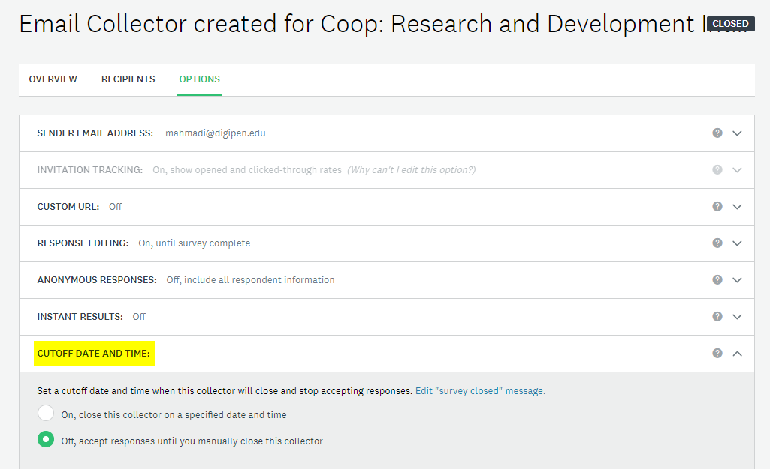
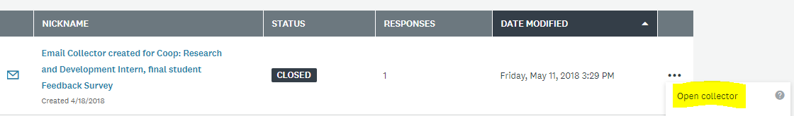
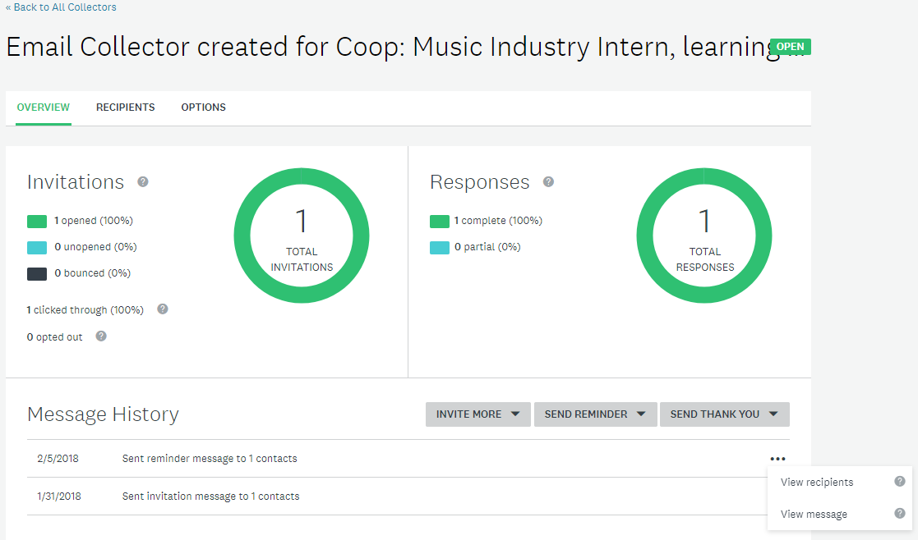

Linking Created Surveys Into GLCC

- Once surveys are created in Survey Monkey, the Admin must manually refresh in GLCC for the surveys to pull over. Other Activities > External Surveys > Next Actions > Refresh Surveys
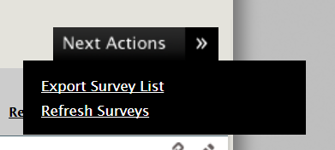

- Your surveys will now be listed on their External Surveys grid under the “Open” tab
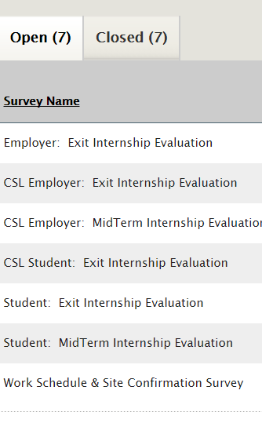
- You must now edit each survey using the “pencil” icon to make it active and choose which “Audience” the survey is for. “Active” will determine if the survey will be an option to select on your semester/individual Co-Op/Internship record. “Prompt” will populate a pop-up message in GLCC upon logging in for those students/employers who have not yet completed the survey. The pop-up will no longer be in effect once they complete the survey. “Co-Op/Internship” will determine whether this survey is for use in the Co-Op/Internship module.
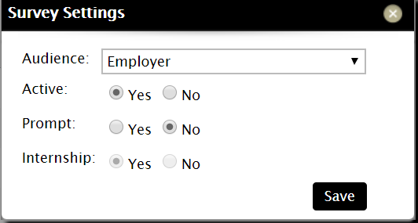

- If the survey is marked as Active and for Co-Op/Internships, that will make those surveys available for assignment in your semester list.
- Once a Co-Op/Internship survey has been sent out and completed, the results can be viewed in GLCC, on the Co-Op/Internship record for that student.
- You can click the binocular icon to view the full results, including the student/employer’s answers to each question.

