How to set up a Quick Search on the Job Search Menu (Admin only)
This feature allows an Admin to add a Job Search agent (Quick Search) for a subset of students based on criteria. The link to these jobs will appear in the student Job Search menu. It will only appear to those students who match the criteria.
Searches can be set up for a Position Type (Full-Time, Part-Time, Internship), Class Year or Program.
If you do not see the Student Quick Search tab, contact support@gradleaders.com to set it up.

How it works:
Run a search on the Job grid. Ex. Search for Internship jobs.
Click on Save Search.
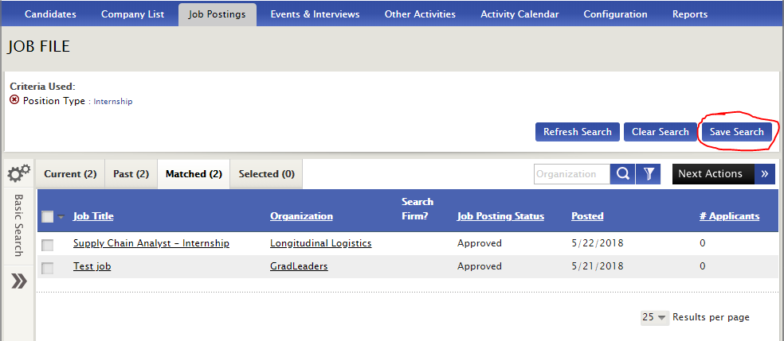
Click on Save as New Search to enter the name of your Search.
Click Save.

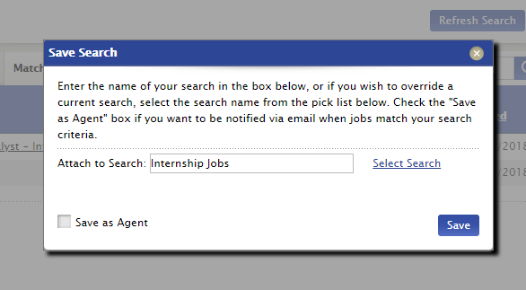
Go to Job Postings > Saved Searches & Agents.
In the My Saved Searches tab, add the search to Quick Search by clicking on the +.
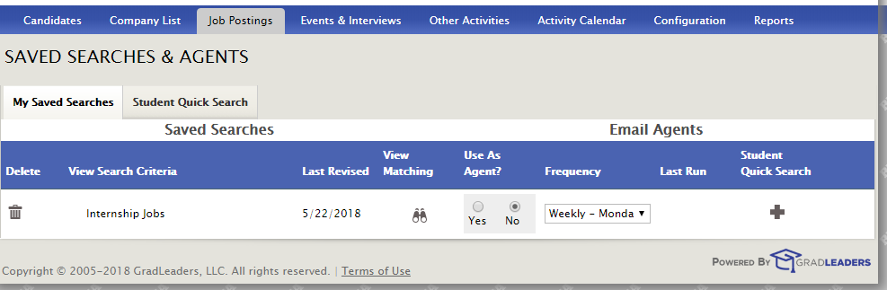
Select your criteria in the Edit Student Quick Search page. Click Save.
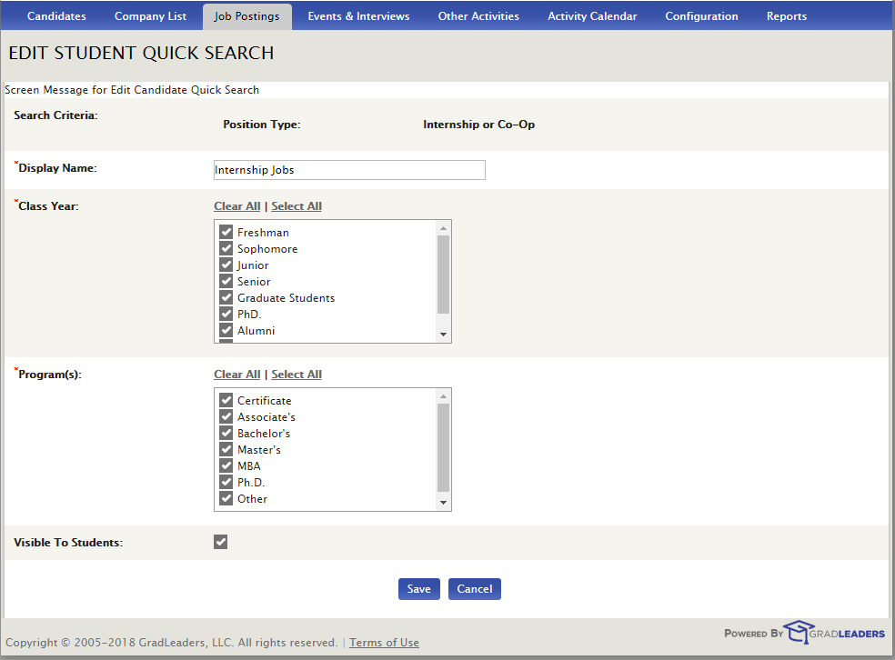

The Student Quick Search tab in Saved Searches will show all the Saved Quick Searches.
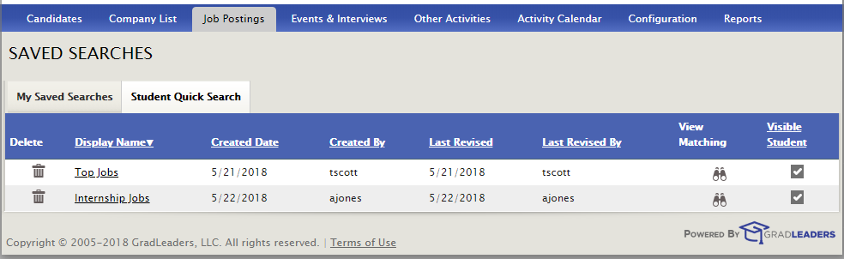

NOTE: With this feature, the menu option shows up for candidates that match the quick search criteria only.
